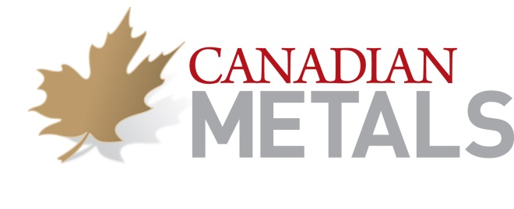

Canadian Metals Inc. CSE: CME

Nadege Tollari Ph.D. joins the Canadian Metals team

Febuary 20, 2015 – Montreal, Quebec – Canadian Metals Inc. (the “Corporation”) (CSE: CME) is proud to announce the arrival of Mrs Nadege Tollari amongst its team as the Special Advisor of Canadian Metals. Mrs Tollari will work closely with all the Corporation’s directors for the development of the Corporation.

Mrs Tollari worked for Arianne Phosphate Inc. (alternate name: Arianne Resources Inc.) from 2008 to 2014. She served as geologist and corporate assistant, Vice-President, Research & Development and Vice-President Corporate Affairs. She was mainly involved in the development of the Lac à Paul phosphorus-titanium project, as well as the implementation of the sustainable development policy of the company and the implementation of the relationship program with communities. Mrs Tollari works since February 2014 for Mine Arnaud. Mrs. Tollari holds a Ph.D. and a Postdoctoral fellowship in geology from Universite du Quebec in Chicoutimi. During her four years of research, she focused on Grenvillian rocks and in particular on phosphate minerals associated with iron and titanium oxides.

" Nadège Tollari professional experience will benefit our team with her skills in social acceptability, management, and development of the mining project. This appointment demonstrates our strong commitment to integrate our project in the community while respecting the fundamental principles of sustainable development. We are very pleased to welcome to our ranks a person who has been able in recent years to develop such expertise in Quebec "said Stephane Leblanc , CEO of the Company.

About Canadian Metals
Canadian Metals Inc. is focused exclusively on the exploration and development of its Langis Project, a high-purity silica deposit located in the province of Quebec. The Company is rapidly positioning itself to become a future producer of ferrosilicon in North America

Neither the CSE nor its Regulation Services Provider accepts responsibility for the adequacy or accuracy of this release.

For more information, please contact:

Stéphane Leblanc
President and CEO
Tel.: (418) 717-2553
Email: sleblanc@canadianmetalsinc.com
Website: www.canadianmetalsinc.com

